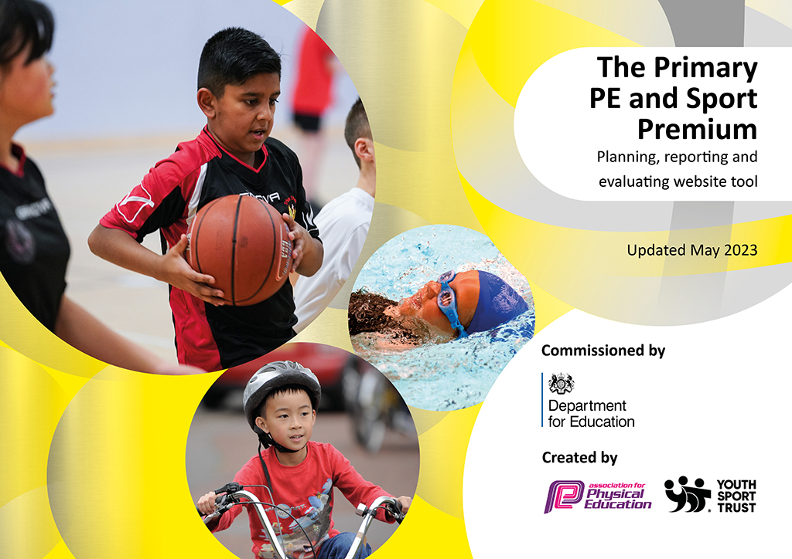
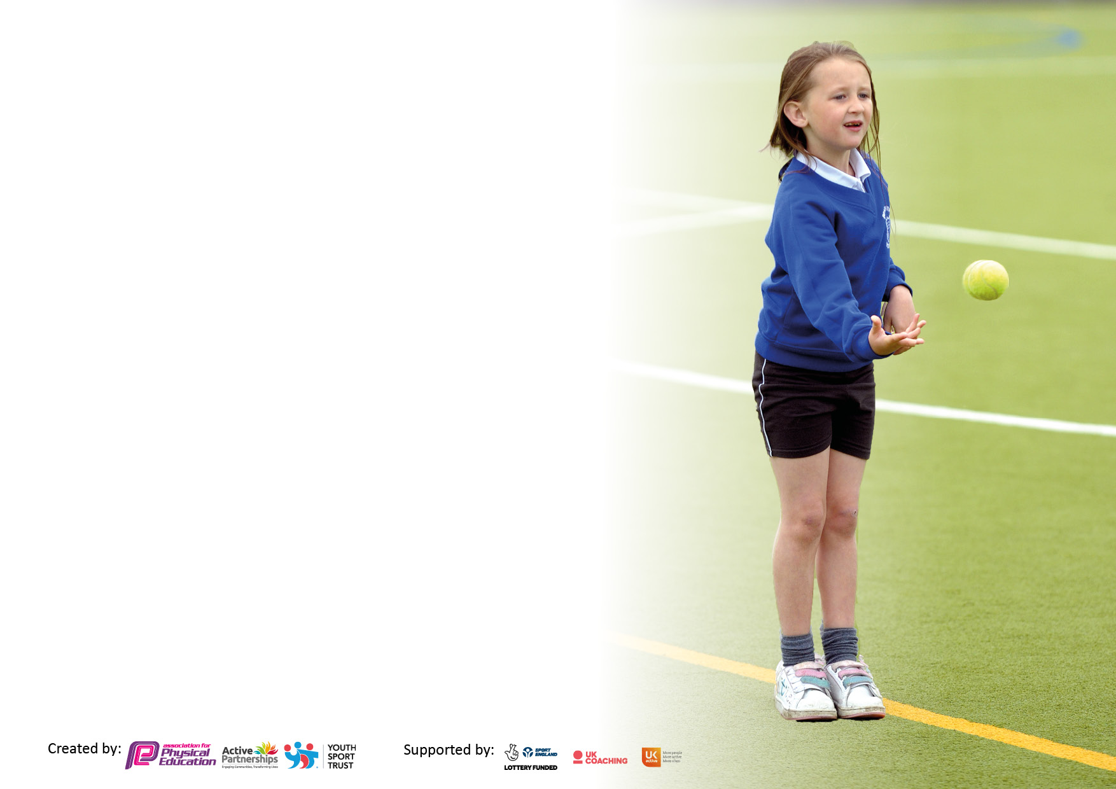

It is important that your grant is used effectively and based on school need. The Education Inspection Framework makes clear there will be a focus on ‘whether leaders and those responsible for governors all understand their respective roles and perform these in a way that enhances the effectiveness of the school’.

Under the Quality of Education Ofsted inspectors consider:
Intent - Curriculum design, coverage and appropriateness
Implementation - Curriculum delivery, Teaching (pedagogy) and Assessment
Impact - Attainment and progress

To assist schools with common transferable language this template has been developed to utilise the same three headings which should make your plans easily transferable between working documents.

Schools must use the funding to make additional and sustainable improvements to the quality of Physical Education, School Sport and Physical Activity (PESSPA) they offer. This means that you should use the Primary PE and sport premium to:

- Develop or add to the PESSPA activities that your school already offer
- Build capacity and capability within the school to ensure that improvements made now will benefit pupils joining the school in future years
- The Primary PE and sport premium should not be used to fund capital spend projects; the school’s budget should fund these.

Please visit gov.uk for the revised DfE guidance including the5keyindicatorsacrosswhichschoolsshoulddemonstrate an improvement. This document will helpyoutoreviewyourprovisionandtoreportyourspend.DfEencouragesschools to use this template as an effective way of meeting the reporting requirements of the Primary PE and Sport Premium.

We recommend you start by reflecting on the impact of current provision and reviewing the previous spend.

Schools are required to publish details of how they spend this funding, including any under-spend from 2021/2022, as well as on the impact it has on pupils’ PE and sport participation and attainment. The funding should be spent by 31st July but the DfE has stated that there will be no clawback of any unspent money so this can be carried forward into 2023/24.

We recommend regularly updating the table and publishing it on your website throughout the year. This evidences your ongoing self-evaluation of how you are using the funding to secure maximum, sustainable impact. Final copy must be posted on your website by the end of the academic year and no later than the 31st July 2023. To see an example of how to complete the table please click HERE.

Details with regard to funding
Please complete the table below.

Total amount carried over into 2021/22 | £13,344
Total amount allocated for 2021/22 | £17,250
How much (if any) do you intend to carry over from this total fund into 2022/23? | £2,946
Total amount allocated for 2022/23 | £17,200
Total amount of funding for 2022/23. Ideally should be spent and reported on by 31st July 2023. | £20,146
Swimming Data
Please report on your Swimming Data below.

Meeting national curriculum requirements for swimming and water safety.

N.B. Complete this section to your best ability. For example you might have practised safe self-rescue techniques on dry land which you can then transfer to the pool when school swimming restarts.
Due to exceptional circumstances priority should be given to ensuring that pupils can perform safe self rescue even if they do not fully meet the first two requirements of the NC programme of study
What percentage of your current Year 6 cohort swim competently, confidently and proficiently over a distance of at least 25 metres?  N.B. Even though your pupils may swim in another year please report on their attainment on leaving primary school at the end of the summer term 2023.  Please see note above | 60%
What percentage of your current Year 6 cohort use a range of strokes effectively [for example, front crawl, backstroke and breaststroke]?  Please see note above | 60%
What percentage of your current Year 6 cohort perform safe self-rescue in different water-based situations? | 42%
Schools can choose to use the Primary PE and sport premium to provide additional provision for swimming but this must be for activity over and above the national curriculum requirements. Have you used it in this way? | No

Action Plan and Budget Tracking
Capture your intended annual spend against the 5 key indicators. Clarify the success criteria and evidence of impact that you intend to measure to evaluate for pupils today and for the future.

Academic Year: 2022/23 | Total fund allocated: | Date Updated: 20.07.23
Key indicator 1: The engagement of all pupils in regular physical activity – Chief Medical Officers guidelines recommend that primary school pupils undertake at least 30 minutes of physical activity a day in school
Intent | Implementation |  | Impact
Your school focus should be clear what you want the pupils to know and be able to do and about  what they need to learn and to  consolidate through practice: | Make sure your actions to achieve are linked to your intentions: | Funding allocated: | Evidence of impact: what do pupils now know and what can they now do? What has changed?: | Sustainability and suggested next steps:
Increase children’s engagement in physical activity during break and lunch times – self-directed physical activities. | - Clear rotas for use of equipment drawn up and displayed for each term  - Supervising staff encourage all children to participate  - Continue with coach led lunch clubs for both KS1 and KS2  - Year 6 Sports Ambassadors trained as play leaders to deliver focused active sessions for younger children | £1,000 | Maintaining increased numbers of children engaged in physical activity on the school field.  Equipment in use and having two football pitches has allowed staff to ensure that older and younger children have equal access to playing game. Two pitches also allows football club to run at lunchtime whilst those not part of club can still access football.  Lunchtime clubs provided by external coaches have allowed an increased number and age range of children to receive structured sports provision and coaching throughout the year. | - Maintain clear rotas for use of equipment during lunchtimes  - Continue with coach led clubs for KS1 and KS2  - Expand support provided by Y6 sports ambassadors by training to deliver specific activities and providing accessible equipment separate from main PE equipment.
Key indicator 2: The profile of PESSPA being raised across the school as a tool for whole school improvement
Intent | Implementation |  | Impact
Your school focus should be clear what you want the pupils to know and be able to do and about  what they need to learn and to  consolidate through practice: | Make sure your actions to achieve are linked to your intentions: | Funding allocated: | Evidence of impact: what do pupils now know and what can they now do? What has changed?: | Sustainability and suggested next steps:
Raise the profile of PESSPA through sharing information about inspiring sportsmen and women who are positive role models for our community. | - Continue to build bank of inspirational sportspeople  demonstrating that everyone is included and can succeed in their chosen sport.  - Investigate further inspirational sportspeople to visit the children and talk about their goals, achievements and experiences in overcoming barriers. | N/A | Children continue to develop their awareness of a range of athletes from different backgrounds.  Children able to recognise our key sportspeople when they take part in events – e.g. Lauren Bell (cricket) and Alfie Hewett (tennis).  Use of bank of role models as part of collective worships linking to key school values, British values and our school equality objectives. | Careful selection of inspirational sportspeople demonstrating that everyone can succeed in their chosen sport.  Link where possible to current sporting events to encourage children to engage with these.  Olympic sportsperson visit booked for Autumn Term to share goals, achievements and experiences in overcoming barriers.
Use of ‘Healthy Living Week’ to raise profile of PESSPA and highlight links with other areas of the curriculum. | - Further strengthen children’s understanding of benefits of being active on wellbeing and mental health.  - Develop central sport and PE display to reference how being active makes us feel.  During ‘Healthy Living Week’ all  children experience:  - Trying a new sport  - Walking a mile every day  - A daily period of mindfulness or  - reflection  - A lesson on mental wellbeing  - A lesson on the importance of  - eating a balanced diet  - A lesson on sleep requirements  - and the benefit of sleep  - An opportunity to  - cook/prepare a healthy meal or  - snack | £500 | Children able to discuss healthy choices in relation to physical and mental wellbeing.  Mental health and wellbeing workshops delivered by the MHST helped children to understand the links between physical feelings and wellbeing strategies and their mental health. | Continue to develop focus on wellbeing and mental health during Healthy Living Week alongside fitness and dietary support.  Ensure children have the opportunity to experience a range of different physical activities.

Key indicator 3: Increased confidence, knowledge and skills of all staff in teaching PE and sport
Intent | Implementation |  | Impact
Your school focus should be clear | Make sure your actions to | Funding | Evidence of impact: what do | Sustainability and suggested
what you want the pupils to know | achieve are linked to your | allocated: | pupils now know and what | next steps:
and be able to do and about | intentions: |  | can they now do? What has
what they need to learn and to |  |  | changed?:
consolidate through practice:
All teachers to:  - Be confident in teaching excellent PE lessons  - Demonstrate progression of skills  - Enjoy teaching PE  All pupils to:  - Enjoy PE lessons  - Have opportunities to take part  - in a range of sports  . | - Continue to follow rolling programme which ensures coverage of a range of sports over 2 years  - Use of coaches to support the teaching of sports and allow the teachers to observe and participate in outstanding practice  - Progression of skills available for sports | £695  £4000 | Children’s improvement in skills assessed as part of delivery of PE curriculum and evidencing impact. | Ensure new staff receive CPD to implement Real PE effectively.
Key indicator 4: Broader experience of a range of sports and activities offered to all pupils
Intent | Implementation |  | Impact
Your school focus should be clear | Make sure your actions to | Funding | Evidence of impact: what do | Sustainability and suggested
what you want the pupils to know | achieve are linked to your | allocated: | pupils now know and what | next steps:
and be able to do and about | intentions: |  | can they now do? What has
what they need to learn and to |  |  | changed?:
consolidate through practice:
All children to have access to a wide range of sports through the PE curriculum.  School ensure a good range of active clubs available during and outside of school hours. | - Use external coaches to allow the pupils to have high-quality PE teaching, whilst also enabling the teachers to acquire the skills and ideas to be able to teach it on their own in the future. |  | Member of staff trained in netball able to deliver after school club.  This year, children enjoyed a morning fencing club for the first time.  Following on from the impact of our whole school adventurous activities at ‘Go Ape’ last year, we hired a climbing wall and allowed every child access to this during a special PE lesson. | Continue to monitor and, if possible, increase range of active clubs available.  Source adventurous activity for 2023-24 to maintain level of challenge for children.
Ensure children have access to a good range of equipment for sports and activities. | - Complete annual audit of equipment  - Monitor use and availability – e.g. during breaks and lunch times  - Ensure appropriate activities and equipment are available to all age categories  Maintain equipment and replace where required | £2000 | All children are able to participate in PE curriculum and planned sports activities.  Equipment purchases have included those aimed at our youngest pupils to support their development of strength, balance and co-ordination and equipment to allow inclusion for children with SEND who requires support with their gross motor skills and accessing the PE curriculum and available sporting activities. | Continue with annual audit of equipment to maintain high quality resources.

Key indicator 5: Increased participation in competitive sport
Intent | Implementation |  | Impact
Your school focus should be clear | Make sure your actions to | Funding | Evidence of impact: what do | Sustainability and suggested
what you want the pupils to know | achieve are linked to your | allocated: | pupils now know and what | next steps:
and be able to do and about | intentions: |  | can they now do? What has
what they need to learn and to |  |  | changed?:
consolidate through practice:
All children to experience competitive sport in a safe and supportive school environment.  Children to have the opportunity to be selected to represent their school at interschool competitions. | School to offer opportunities for children to be selected to represent their school in interschool competitions, e.g West Berkshire Quadkids Athletics Competition  School to offer all children opportunities for children to participate in internal competitions, e.g. school cross country competition  Continue to monitor inclusion and participation of vulnerable groups in competition.  Train additional staff as mini-bus drivers to due to increased costs of hiring coaches.  Purchase sports kit for children and staff for interschool sports and PE lessons. Ensure safety, inclusivity and belonging. | £4,630 | We took part in both KS2 and KS1 interschool sports events allowing children to work as a team, compete against children from other schools and develop confidence. Children selected to represent our school included those from a range of vulnerable groups.  100% of children have participated in whole school competitions, including  - School cross country event  - House Group athletics field events – vortex javelin, speed bounce and standing long jump  - School sports day (track events) | Ensure whole school competitions remain a focus of planning for 2023-2024.  Events available post pandemic seems to be slowly increasing. Costs of attending events are challenging – particularly in view of increase in transport costs despite our investment in training staff as minibus drivers. Consider holding more internal competitions to provide children with access to cost effective sporting events or small events with other local schools.  Continue to monitor inclusion and participation of vulnerable groups.

